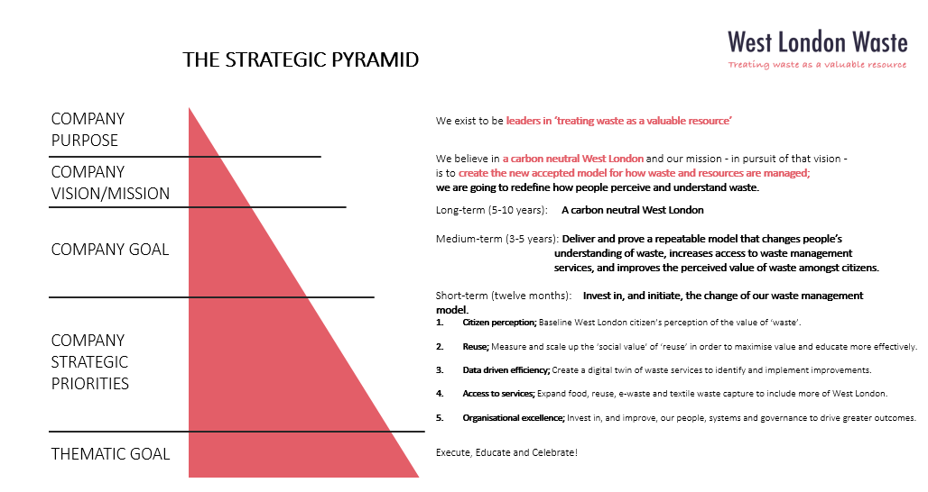
Appendix 2 – WLWA Business Plan 2023/24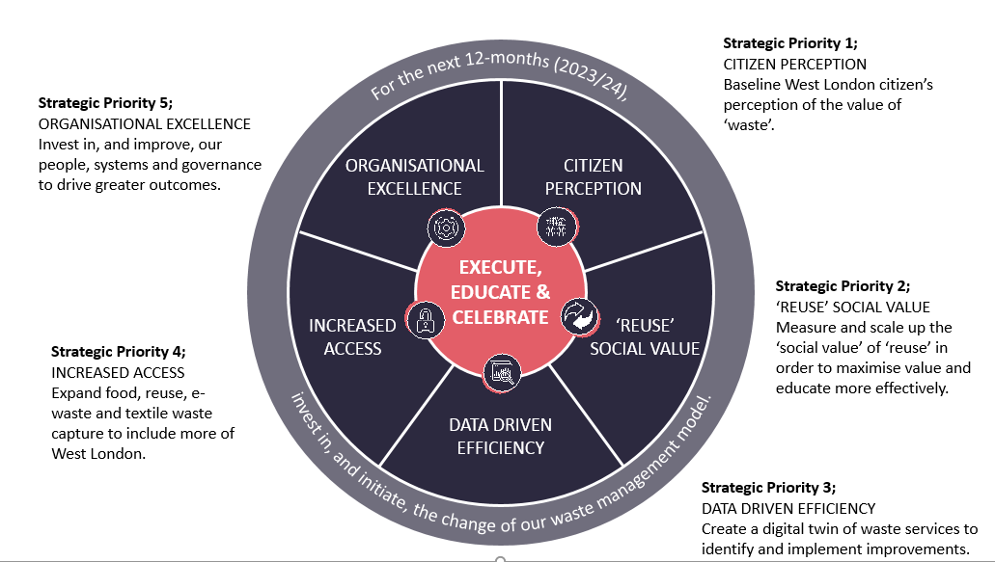

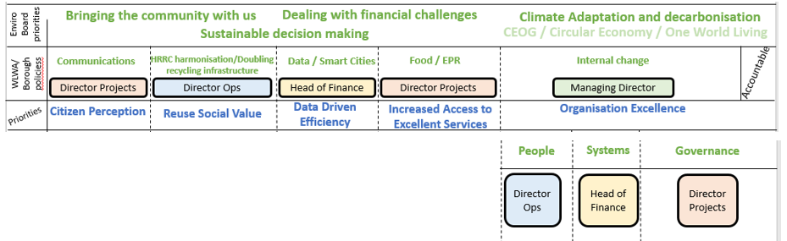

Strategic Priorities 1-4 are being updated and refined by the Accountable owners.
Strategic Priority 5 has been re-written. Feedback from the Leaders and Managers two away days will be incorporated to develop next steps.

